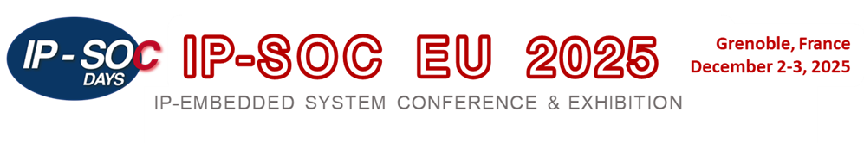
Silver* Sponsorship Package: D&R Partner $2K – Non D&R Partner $3K

  - Event options - select your wishes
    - One 20mn talk
    - Exhibition table
    - Video Interview at the event
  - Promotion on line virtual edition ( if a 20mn talk is selected)
    - Slides posted on line
    - Recorded talk /interview posted on YouTube promoted on D&R Website
    - On line audience tracking
  - News Alert and mailing
    - Banner as sponsor in all program mailings or any advertisement related to the event
    - Interview, Slides and Recorded talk promoted in D&R News Alerts sent to 36.000 destinations during the 4 months following the event

* For participants willing to have more than 1 contribution please update to
- Gold Sponsorship Package: $3K – Non D&R Partner $4K

Sponsorship package subscription
INFORMATION
Company name
Contact name | Contact email
Speaker Name & Position
Tentative Talk Title

Signature: | Date:

RETURN a signed copy to gabriele.saucier@design-reuse.com

